

GET API

&

PERMISSION

{----------------------------------------------------------}



-------------------------------------------------------------------------------------------------------



Use Your API & Access Token with Python Program to get tweets and replies

Get Your API & Access Token by

Creating App in Twitter Dev. Acc.

Confirm Your Email

Researcher

Apply for Twitter Developer Account

Collect Your Data Either In JSON/CSV

-------------------------------------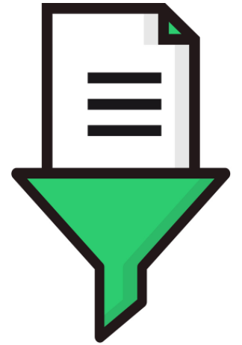------------------------------------------------------------------

-------------------------------------------------------------------------------------------------------

**Research**

**Predicting cyber bullying using data mining**





Visualize & Convert Your Output Data into Graphs & Chart

Apply Your Models/Algo with Python Program

Preprocess Your Data/Filter Your Data

Write Your Theory Work & You are Done with Your Research Work